National University of Computer and Emerging Sciences


Lab Manual 2
“Introduction to MS SQL Server, DML and DDL”
Database Systems Lab
Spring 2023

Department of Computer Science
FAST-NU, Lahore, Pakistan

Table of Contents
1. Objective 2
2. Task Distribution 2
3. Getting Started with Microsoft SQL server 3
Step 1: Open SQL server management Studio 3
Step 2: Connect to Server 3
Step 3: Create your own Database 4
Step 4: View and use you database 7
4. Data Definition Language: 7
Step 1: Create table: 8
Step 2: Altering table 8
Adding new column to existing table 8
Drop existing Column from existing table 8
Step 3: Add Primary key Constraint. 9
Step 4: Add foreign key constraint to tables 10
5. Data Modification Language 11
Step 1: Insert rows into table 11
Step 2: To see the data from you table use the following table 12
Step 3: Delete rows from the table 12
Step 4: Delete all the data from the table 12
Exercise 14
Appendix 15
Comments is SQL 15
Data Types 15
Where Conditions 17

Objective
The purpose of this lab is to introduce students to Microsoft SQL server environment and getting started with Data definition queries and Data modification queries.

Prerequisites
You should know the concepts of Primary key, foreign key and how to identify these constraints from the given schema. You have to read the manual before coming to lab.

Task Distribution

Total Time | 170 Minutes
Introduction to MSSQL | 20 Minutes
DDL | 30 Minutes
DML | 30 Minutes
Exercise | 90 Minutes
Evaluation | --

Getting Started with Microsoft SQL server
In this section you will learn how to create open SQL server, connect with the database server, and create your new database (through design view and query as well).

Step 1: Open SQL server management Studio
Go to Start Menu and search for SQL Server Management Studio, open it

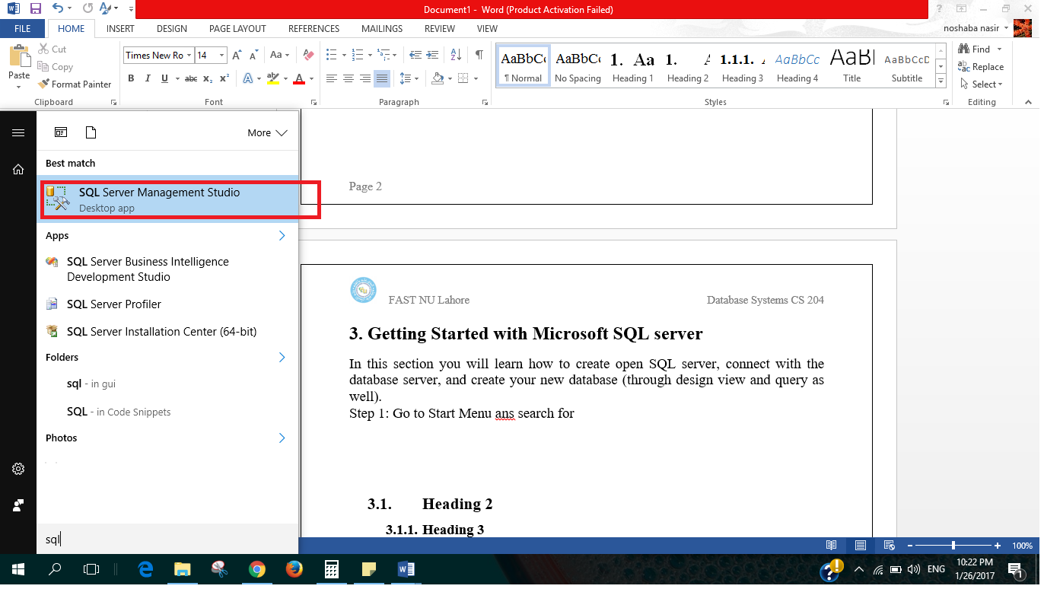

Step 2: Connect to Server
One the left side you have object Explorer which you will use to explore all your databases and any object you create such as tables, on right there is Dynamic Help.
In the middle you can see Connect to server dialogue box.
Select SQL Server Authentication from Authentication Drop down
Ask for login and password from your lab instructor and press Connect
(refer to following figure)
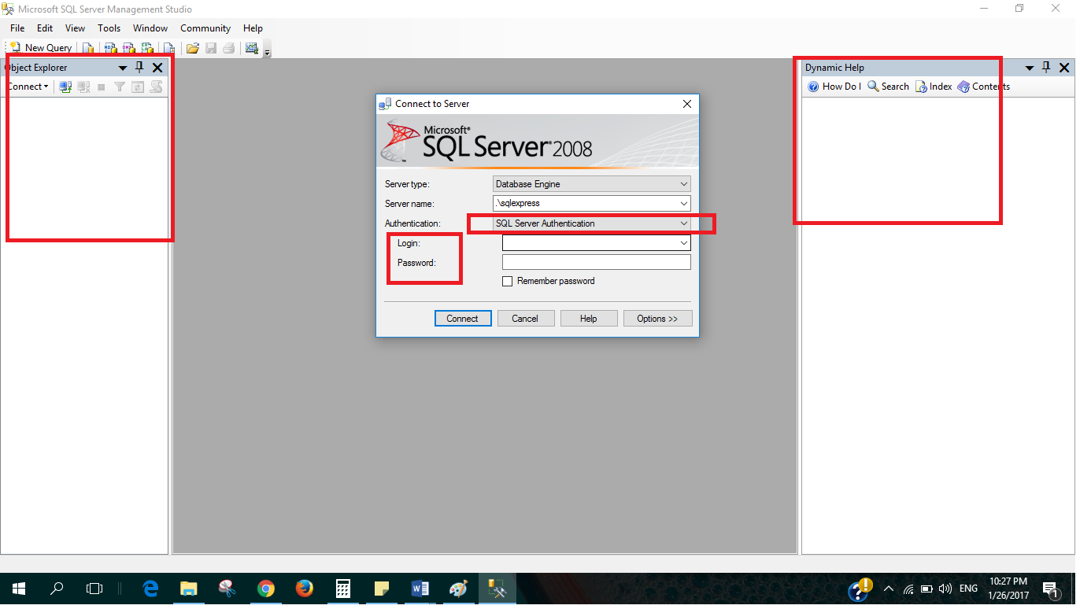

Step 3: Create your own Database
There are two ways to create a new data base
- Through Query
>>Click on New Query, a new blank page will open (as shown in following figure)
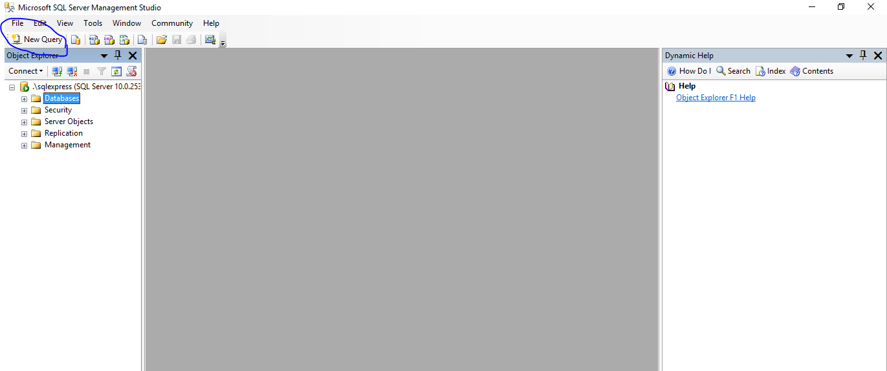

>>Write the following query on this page
create database <nameofyouDatabase>
>>Hit Execute button shown on top, Command completed successfully shows that you database has been created. (As shown in following figure)

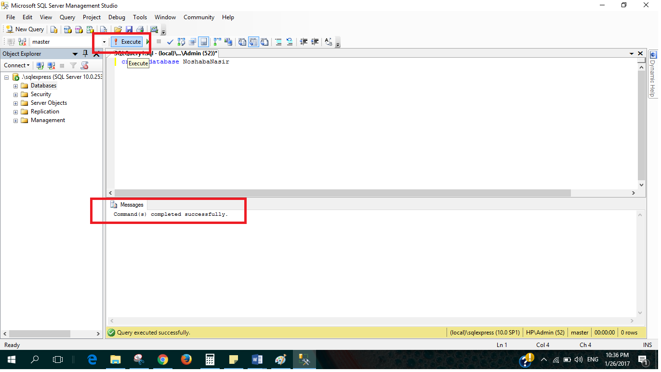

>>If you want to delete your database write the following query and Execute, make sure that the command is executed successfully.

drop database <DatabaseName>

You can also create new database by Left click on Database from object Explorer and select new Database, give it a name and press ok (as shown in following figures).
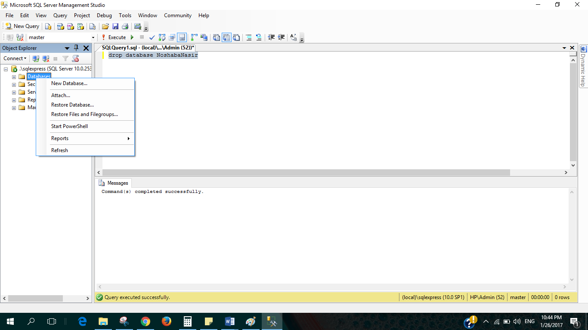
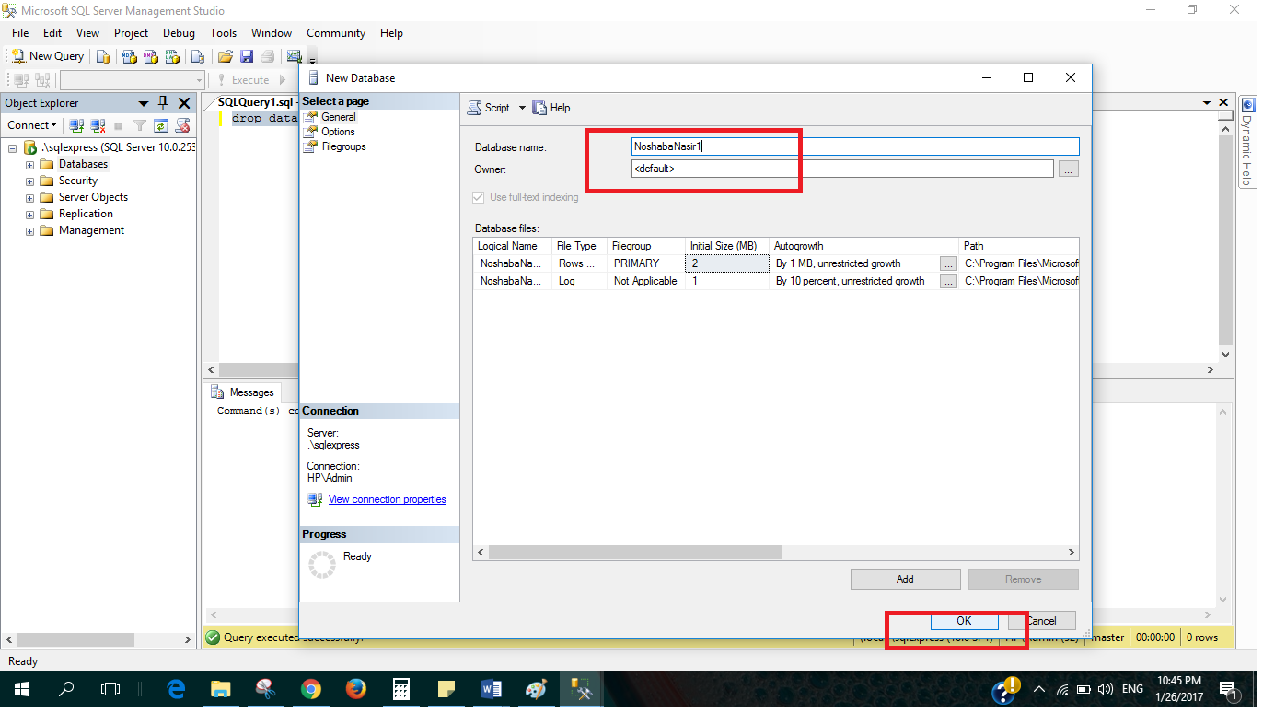

Step 4: View and use your database

If you expand the Database from object explorer, you can see all of the databases that exist of the server, including the newly created ones (as shown in following figure).
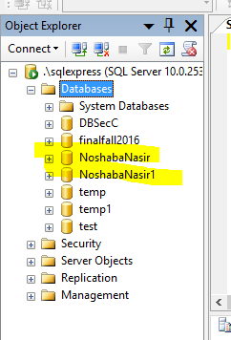
To use your database, make sure to select your database from drop down menu (as shown in following figure).
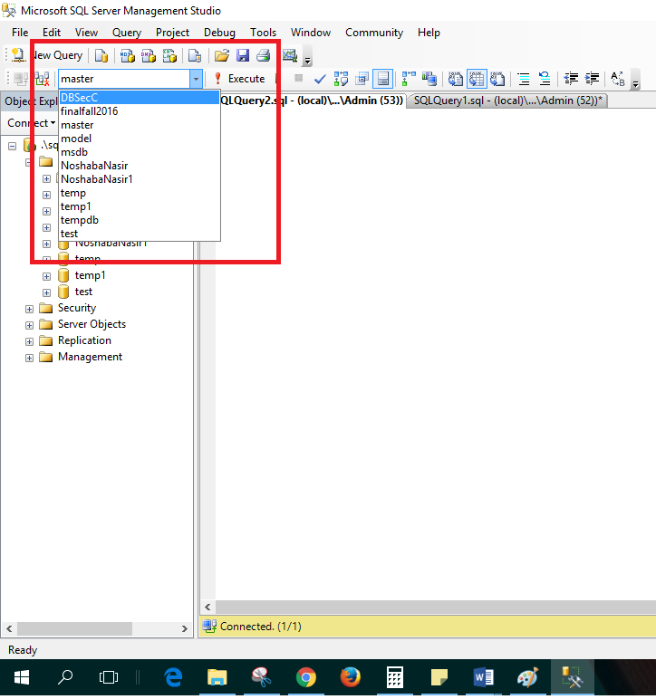

Or you can use the following query to use your database.

Use <databaseName>

Data Definition Language:
Also called DDL includes creating objects such as tables, adding constraints of tables, such as FK PK unique constraints, in this section you will learn how to create tables and add PK, FK constraints using Queries.

Step 1: Create table:
Following is the syntax of table creating query

create table [tablename]
(
[Column1Name] datatype null/Not null,
[Column2Name] datatype null/not null,
[Column2Name] datatype null/not null
)
*null is default

Create the table Students using the query as shown in following figure, Execute, make sure the message shows that the command is successful.
Go to object explorer and find you table.
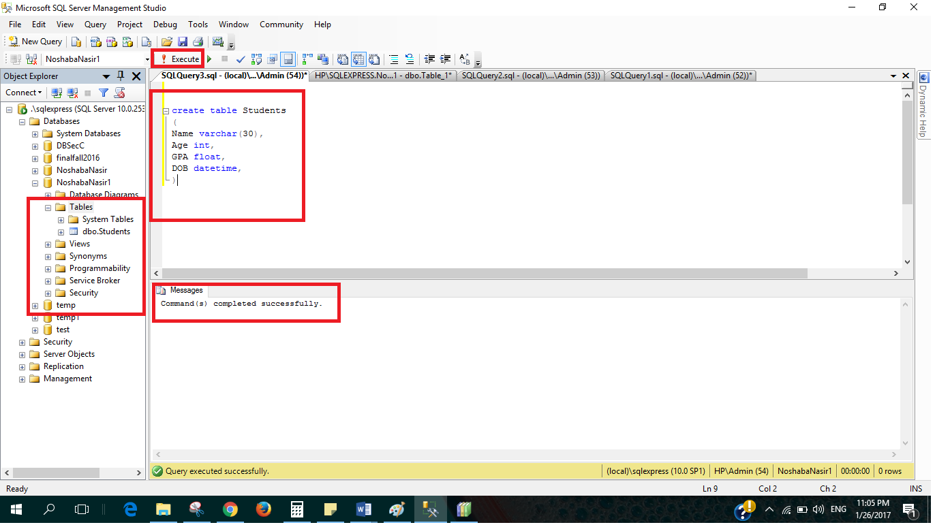

Step 2: Altering table Schema

Adding new column to existing table
alter table <TableName> add <NewColumn> <Datatype>
Try this query
alter table Students add Address varchar(50)

Drop existing Column from existing table
alter table <TableName> drop column <ColumnName>
Try this query
alter table Students drop column [Address]

Step 3: Add Primary key Constraint.

One way to create Primary key is to add it whilst creating table using the following syntax
create table [tablename]
Try the following query, see in object explorer
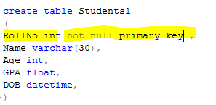
Primary key should be not null
(
[Column1Name] datatype primary key,
[Column2Name] datatype,
[Column2Name] datatype
)
OR if there is composite key
create table [tablename]
(
[Column1Name] datatype,
[Column2Name] datatype,
[Column2Name] datatype,
Primary key ([Column1Name], [Column2Name])
)

Try the following query, see in object explorer
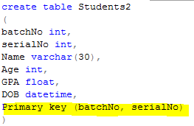

Other way is to add Primary key constraint after creating the table, by using ALTER query,
alter table [tableName] add constraint [keyContraintName] Primary key (Column1, column2, column3)
Try the following, PK columns should be not null
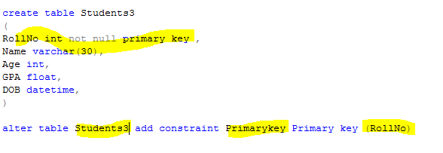

How to see the schema of your table
Try this to see the schema of your table

sp_help <tableName>

This will give you information about colums, their datatype and all the constraints on the table.

Step 4: Add foreign key constraint to tables
Before creating FK constraint Make sure that the referred table and its referred columns are created.

Add FK whilst creating table.
Use the following syntax as given.

create table [tablename]
(
[Column1Name] datatype Null/Not Null,
[Column2Name] datatype Null/Not Null,
[ReferencingColumn] datatype Null/Not Null
FOREIGN KEY REFERNCES referedtable(referedColum)
ON DELETE NO ACTION/CASCADE/SET NULL/SET DEFAULT
ON UPDATE NO ACTION/CASCADE/SET NULL/SET DEFAULT
)
*no action is default
Try the following, and see in object explorer.
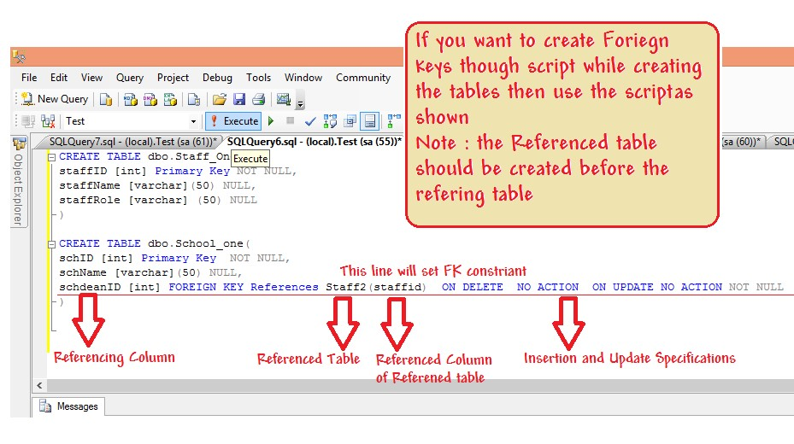

FK can also be added after the referencing and referred tables have been created.
Try the following and see in object explorer
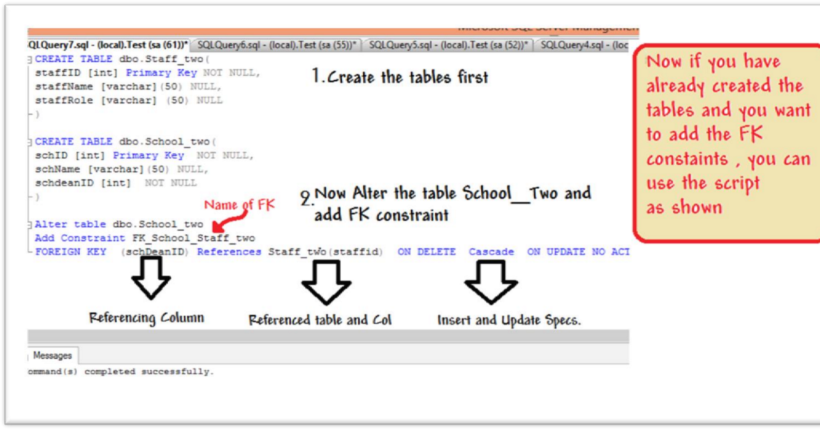

Data Modification Language

Step 1: Insert rows into table
Syntax
-- let there be N columns in a table
INSERT INTO <tableName>
values
(Column1Value,Column2Value, Column3Value,….,ColumnNValue), --row 1
(Column1Value,Column2Value, Column3Value,….,ColumnNValue), --row2
(Column1Value,Column2Value, Column3Value,….,ColumnNValue) –row 3

Or
INSERT INTO <tableName> (ColumnX,ColumnY) -- List of Columns
values
(ColumnXValue,ColumnYValue), --Row 1 list of Corrrespong column values
(ColumnXValue,ColumnYValue), --Row 2
(ColumnXValue,ColumnYValue) –Row 3

Try the following
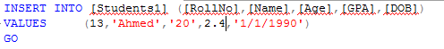
Try the following
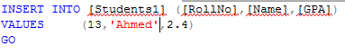

Step 2: To see the data from you table use the following table
Select * from tableName

Try the following and see the results
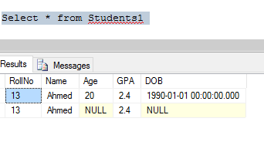

Step 3: Delete rows from the table
Delete from <tableName>
Where <conditions>

Try the following and see the message and data in table using select query

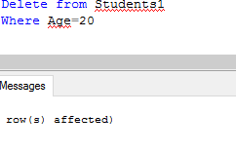

Step 4: Delete all the data from the table
Delete from <tableName> --as there is no where condition all rows will be deleted
Or
Truncate table <tableName>

Try these two commands after adding some rows to the table and see the results.

Step 5: Updating the rows
Update tableName
set ColumnA=<NewValue>,
ColumnB=<NewValue>,
where <Conditions>

See the data in table before and after trying the following query
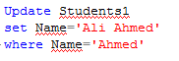

Appendix

Comments in SQL
Comments in SQL server start with two dashes as shown below, in green color

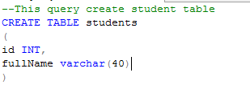

Data Types
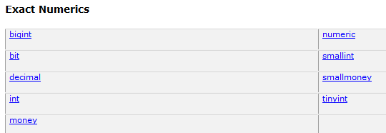
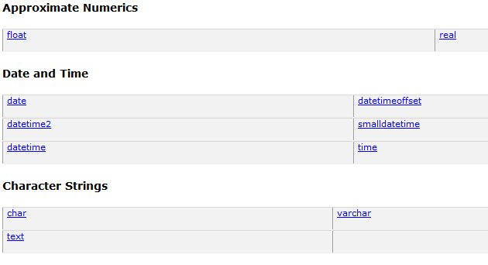
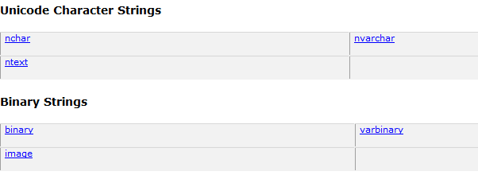

Where Conditions
Or
And
Not
In

Sub queries

In
All
Any
Some
Exists

How to see all the tables in your database:
SELECT * FROM INFORMATION_SCHEMA.TABLES;
Or
select * from sys.tables;
or
SELECT * FROM sysobjects WHERE xtype='U';

How to see details of certain table
sp_help tableName

